Hi Sunny –

Thanks for fixing the outsideRth issue… funny how capitalization of the first letter ended up being the issue. I wonder if it’s a feature that’s not often used and perhaps that’s why the documentation seems to be off.

I tested the buy / sell orders with outsideRth activated and all is working well. All good here!

I’ve been testing the other functionalities, and everything seems to be working well. I am going to continue to test everything (include the portfolio modification function) and I will let you know if any problems arise.

I’d like to pivot and focus on retrieving OHLC data and how best to do so. I also wanted to ask if we can add a few additional features (mentioned at the bottom).

While testing, I’m able to easily pull hourly data for tickers. In the example below, I pulled 3 days worth of hourly data for AAPL:

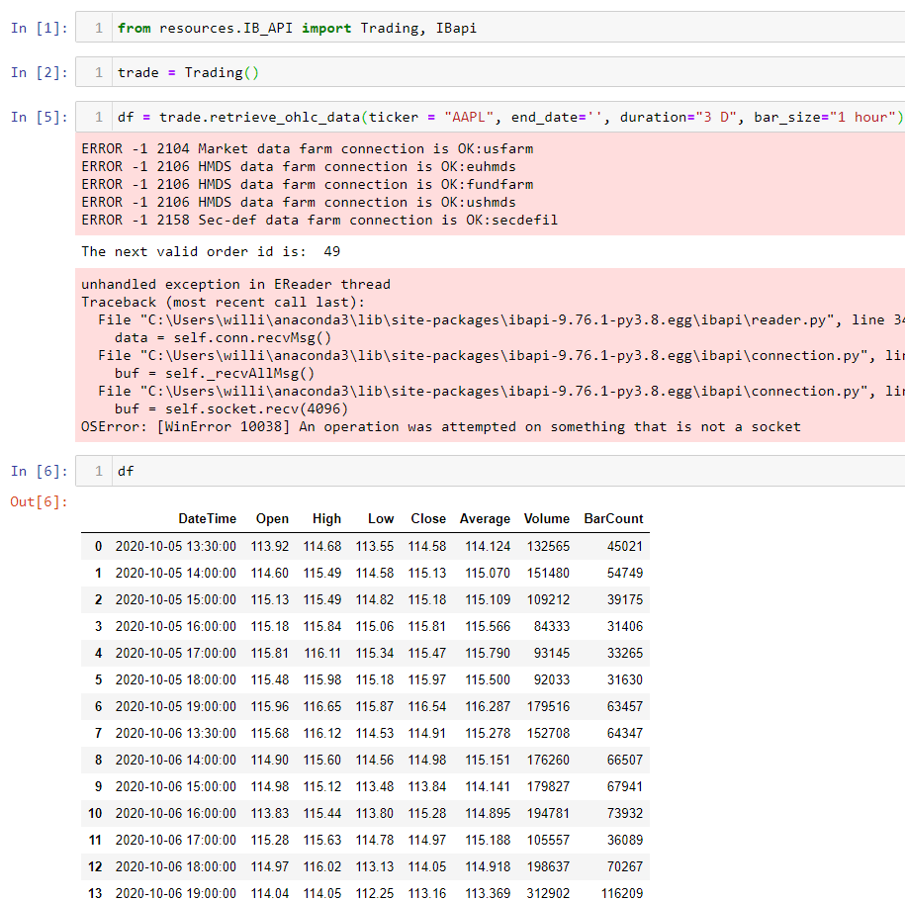

^^^ pulling data by hourly bars looks good.

However, things begin to get strange when I try and pull a long duration worth of daily data. Please see below. I tried to pull 30 days of AAPL daily data. However, the output that’s returned begins at 1970 and appears to be 1-second in time increment.

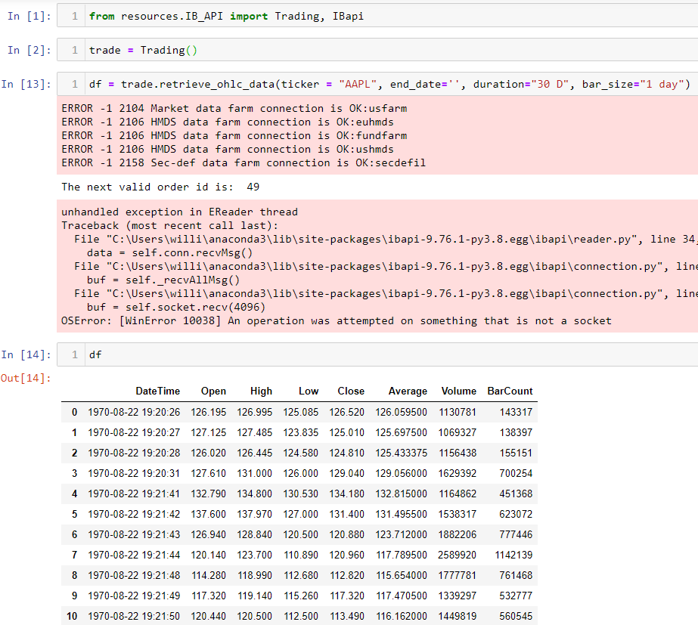

Do you mind looking into the easiest way to properly pull daily data for tickers? My goal is to be able to input a start_date and end_date and pull daily data for any given period of time. For example, being able to pull daily data for AAPL from start_date = 20201007 and end_date = 20100101 and retrieve daily data for each day.

However, I don’t want to minimize the ability of pulling hourly and minute level data too. I really like how it’s possible to also pull 15-minute and 1-hour bars when selected to do so.

Additional features… there are a couple additional features I’d like to have functions created for if possible…

Is it possible to build functions that can retrieve the following…

1 – Most recent bid price for a ticker

2 – Most recent ask price for a ticker

3 – Most recent “mid” price for a ticker

(see below)

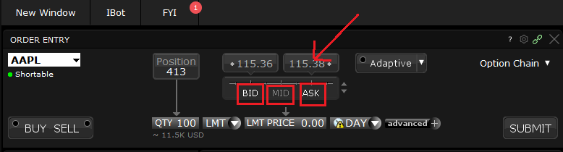

4 - Available hours for trading

Is it possible to create a function that will return the Trading Hours for any given stock as an input? (see below)

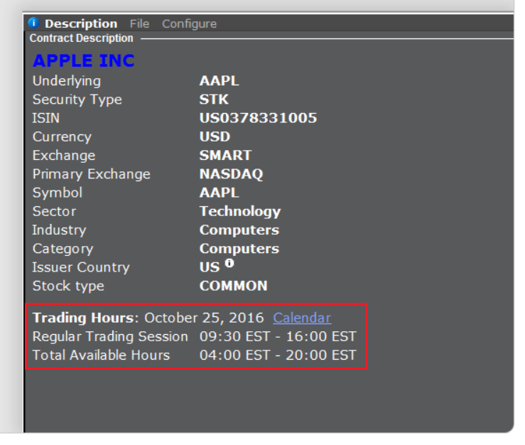

5 – Retrieving bulk OHLC data for multiple tickers

I’m not sure if this next functionality is possible using the IB api but thought I’d ask…

I’ve noticed that prior to each request to IB, we are starting the app… and then after whatever information was retrieved is returned, we then have to disconnect the app and usually time.sleep for a few seconds to give the app time to finish what it’s processing.

This is perfectly fine for most requests… except for when trying to retrieve data for many many tickers at the same time. In the below example, I was able to pull historical data for 100 tickers in about 5-10 seconds. Is it possible to create python logic that will start the IB “app” using self.start_app_in_background(app) and pull data for a ticker list before shutting back down the app? I’m not sure if this is feasible but I am trying to see if there is a way to quickly pull bulk data for multiple tickers.

